**MIGRANTWORKERS TRACKING SYTSTEM**

**PROJECT REPORT(ROUGH)**

Submitted to the University of Kerala in partial fulfillment of the Degree in

Bachelors of Computer Application from UIT,KOTTARAKARA **By**

**ABHAY RAJ R S**

**(Reg.No:33220959002)**

**ASHIB REHMAN B**

**(Reg.No:33220959016)**

**SOJIN RAJU**

**(Reg.No:33220959039)**



**DEPARTMENT OF COMPUTER SCIENCE**

# UNIVERSITY INSTITUTE OF TECHNOLOGY

(Affiliated to the University of Kerala) Kottarakara, Kollam (Dist), Kerala-691533

**Internal guide:**

# Mrs. THANKAM.S

Associate Professor

Department of Computer Science

UIT, Kottarakara,Kollam-691533

# INTRODUCTION

## 1.1 ABOUT THE PROJECT

This system using the cards, one can travel in any KRSTC buses across the state during a definite time by paying in advance. The card will offer unlimited travel for 3 month and can be renewed at the end of it. The prepaid card will be in the range from Rs.1000 to 5000.At the end of 3 months, travellers can change the card online or at bus station.

## ABSTRACT

The **Migrant Wokers Tracking System (MWTS)** is a system that witnessing large inflow of migrant labours from different parts of our country in recent years.Though laboures from state as far as West Bengal,Bihar,Utter Pradesh and Orrisa now flock to kerala.Higher wages for unskilled labours in the state. Large opportunities for employment and shortage of labour,paradoxically despite the high unemployment rate in the state,led to the massive inflex of migrant labours to the state.

The system contain five modules such as admin,agency,insuranceagency,police station, labour commission,workers and provides a facility for migrant workers to register with the state authorities would be engaged for work in the contruction sector.The contruction sector contain large number of migrant workers in the state.Seeking to address their issues properly and now about their whereabout, the government is planning to engage registered labours only in the sector.The government has also introduce a safety plan to ensure the rights of labours.

### MODULES

* **ADMINISTRATOR**
* **AGENCY**
* **INSURANCEAGENCY**
* **LABOURCOMMISION**
* **POLICESTATION**
* **WORKERS**

**1.2 MODULE DESCRIPTION**

The modules included in this system are:

#### 1. ADMINISTRATOR (ADMIN)

An Authorized person can only login to the website. The administrator is a highly secure and totally independent module in our website. When new user send a request to the administrator, manual verification is done and the administrator will send the username and password to the requested user through mails.

The admin control the entire system,as he can add agencies, job providers department,workers and also update news related to the system. There is separate section to add and update the news. The main functions of administrators in our website are as follows:

* Station handling
* Insurance agency handling
* Agency handling
* Communication
* Report checking

#### 2. INSURANCE AGENCY

In this module, the insurance agency can add several schemes for the workers and also checking the application form of the workers.

* Application checking
* Scheme adding
* Registration
* Payment passing
* Communication
* Details verification
* Confirmation adding

#### 3. POLICE STATION

In this module the police has started to audit of migrant workers using their ID cards.

* Report generation and passing
* Communication
* Registration
* Request checking
* Death case passing to labour commission and nearest police station

#### 4. WORKERS

In this module, the authorized agencies can only login to the software. This is highly secure and effective section.The agency can recruit labours

* Salary checking
* Insurance claim
* Attencdance view
* Complaint
* Video conferencing

**5. AGENCY**

In this module, the authorized agencies can only login to the software,it is a highly secure and effective section.The agency can have capacity to recruit the labours. The important feature of agency are as follows:

* Worker registration
* Report verification
* Salary
* Attendance
* Insurance
* Card downloading
* Re-registration
* Notification checkinng

#### 6. LABOUR COMMISSION

The labour commission module in the system has responsible for overall control and efficient administration of his organization and implementing all the provision of labour act and rules .

* Verification
* Worker detail passing
* Report passing
* WPC generation
* PCC checking
* Video conferencing for person confirmation

## SYSTEM ANALYSIS

### 2.SYSTEM ANALYSIS

System study is the way of studying the system with an eye on solving its problem. It is a most essential part of the development of a system. One must know what information is to be gathered, where to find it, how to collect it and how to make use of it for successful development of the system.

System analysis is the phase in which a problem is identified, alternate solution, evolution and most feasible solution recommended. It begin when a user or manager request a study of problem in either an existing system or a projected system.

* A system must be designed to achieve a predetermined objective.
* Interrelationship and interdependence must exist among components
* The objectives of the organization as a whole have a higher priority than the objectives of its subsystem.

.

#### 2.1 REQUIRMENT ANALYSIS

Requirement Analysis is the process of understanding the customer needs and the expectations from a proposed system or application and is well-defined in the software development life cycle. Requirements are descriptions of how a system should behave or description of system properties or attributes. It can alternatively be a statement of what an application is expected to do.

The software requirement analysis process converts the complex tasks eliciting and documenting the requirement of all these users modeling and analyzing these requirements and documenting them as the basis of system design.

##### 2.1.1 EXISTING SYSTEM

In the existing system, the services like applying for concession and other services are still offline. Introducing of D-card was also a big failure in Kerala.

* Wastage of time
* D-card system still not exist
* Concession card procedures are still offline
* Online payment is not possible

##### 2.2 PROPOSED SYSTEM

In the proposed system, the services become online and D-card system is introduced.

From this system both user and ksrtc gets the profit and it saves the time of the user.

###### 2.3 ADVANTAGES OF PROPOSED SYSTEM Advantages

* Online payment is possible.
* Introducing of D-card system
* Services are online
* Avoid wastage of time

###### 2.4 Feasibility study

The main aim of feasibility study is to determine whether it would be functionally and technically feasible to develop the product. The feasibility study involves the analysis of the collection of relevant information relating to the product such as the different data item which would be the input to the system. The processing required to be carried out on these data, the output data required to

be produced by the system, as well as various constraints on the behavior of the system. A feasibility study is rest of the system proposal according to its working, impacton the organization, ability to meet users and effective use of resources. The objective of feasibility study is acquiring the sense of scope of the system.

The development of a computer-based system is more likely to be projects that

are feasible. Three essential factors are involved in the feasibility analysis are:

* Technical feasibility
* Economic feasibility
* Operational feasibility

###### Technical feasibility

This study is carried out to check the technical feasibility, that is, the technical requirements of the system. Any system developed must not have a high demand on the available technical resources client. The developed system must have a modest requirement, as only minimal or null changes are required for implementing this system.

###### Economic feasibility

This study is carried out to check the economic impact that the system will have on the organization. The amount of fund that the company can pour into the research and development of the system is limited. The expenditures must be justified. Thus, the developed system as well within the budget and this was achieved because most of the technologies used are freely available. Only the customized products had to be purchased.

###### Operational feasibility

One of the main problems faced during development of a new system is getting acceptance from user. Even if a system is technically and economically feasible but the users of the system are resistant to use it then there is no use. In this stage the following issues are considered.

* Is the proposed system is user friendly?
* Is there sufficient support for the project from the management and users?
* Will the proposed system cause harm?
* Will it have proposed poor result in any area?
* Will loss of control result in any area?

The proposed system is so effective, user friendly and functionally reliable that the users will find it that the new system reduced their effort. Since the users are very much involved in planning and development of the project there cannot be any resistance from the management and the reactions are favorable. The result produced is accurate and optimized. The proposed system will have good control on all parts of the organization and it will take care of current activities.

**SOFTWARE REQUIRMENT**

##### PHP

PHP is a server-side scripting language designed for web development but also used as a general-purpose programming language. Originally created by Rasmus Lerdorf in 1995. The reference implementation of PHP is now produced by The PHP Group. While PHP originally stood for Personal Home Page, it now stands for PHP: Hypertext Preprocessor, a recursive acronym.

PHP code is interpreted by a web server with a PHP processor module which generates the resulting web page: PHP commands can be embedded directly into an HTML source document rather than calling an external file to process data. It has also evolved to include a command-line interface capability and can be used in standalone graphical applications. PHP is free software released under the PHP License, which is incompatible with the GNU GeneralPublic License (GPL) due to restrictions on the usage of the term PHP. PHP can be deployed on most web servers and also as a standalone shell on almost every operating system and platform. free of charge.

The PHP interpreter only executes PHP code within its delimiters. Anything outside its delimiters is not processed by PHP. The most common delimiters are <?php to open and"> to close PHP sections. <script language="php"> and </script> delimiters are also available, as are the shortened forms <? or <? = and?> as well as ASP-style short forms <% or <%= and %>. WW1e short delimiters are used, they make script files less portable as support for them can be disabled in the PHP configuration, and so they are discouraged. The purpose of all these delimiters is to separate PHP code from non-PHP code, including HTML.

Much of its syntax is borrowed from C. Java and Perl with some unique features thrown in. The goal of the language is to allow Web developers to write dynamically generated pages quickly.

###### Advantages of PHP

* Cost is low

* PHP is an open-source software

* PHP is easy to learn

* PHP is embedded within HTML

* The HTML-embedding of PHP has many helpful consequences.

* PHP can quickly be added to code produced by WYSIWYG editors.

* PHP can reduce labour costs and increase efficiency due to its shallow learning curve and ease of use.
* PHP has Cross-platform compatibility

* PHP is not tag-based

* PHP is much faster for almost every use than CGI scripts.

* PHP makes it easy to communicate with other programs and protocols.

* PHP is fast becoming one of the most popular choices for so-called two-tier development.

* PHP is developed and supported in a collaborative fashion by a worldwide community of users.

###### Hyper Text Transfer Protocol (HTTP)

HTTP is the protocol "spoken" by web servers. Client programs that can speak I-ITT P. known as browsers, are used by the people on the Internet to connect to HTTP servers. The servers provide access to distributed hyper linked documents, applications and databases. HTTP is a stateless. object oriented application-level protocol that has been in the existence since the early days of the [WWW. N](http://www/)SCA HTTP is a HTTP/1.0 compliant web server and is credited with being one of the first HTTP servers available. It supports multiple schemes of authentication.

###### Html-The Frame Work For Webpages

Hypertext Mark-up Language (HTML) is the text mark-up language on the World Wide Web. The mark-up commands applied to the web-based content tell the browser software the structure of document and, when, how we want the content to be displayed. It has a well-defined syntax and HTML documents have a formal structure. With the introduction of scripting languages such as JavaScript, the concept of dynamic HTML (DHTML) is becoming more and more popular and is used to create highly interactive web pages. When browser reads a document that has html markup in it, it determines how to render it on screen by considering the html elements embedded within the document.

#### CSS

* CSS stands for Cascading Style Sheets
* Styles define how to display HTML elements
* Styles were added to HTML 5. 0 to solve a problem
* External Style Sheets can save a lot of work External Style Sheets are stored
* All browsers support CSS today.

##### SUBLIME TEXT 3

Sublime text is a proprietary cross-platform source code editor with a PythonApplication Programming Interface (API). It natively supports many programming languages and markup languages, and functions can be added by users with plugins, typically community-built and maintained under free-software licenses. Version 3 entered beta on 29 January 2013. At first available only for registered users who had purchased Sublime Text 2, on 28June 2013 it became available to the general public. However, the very latest development builds still required a registration code. Sublime Text 3 was officially released on 13 September 2017.

Two of the main features that Sublime Text 3 adds include symbol indexing and pane management. Symbol Indexing allows Sublime Text to scan files and build an index to facilitatethe features Goto Definition and Got Symbol in Project. Pane Management allows users to move between panes via hotkeys.

**BOOTSTRAP**

Bootstrap is a free and open-source CSS framework directed at responsive, mobile-first front-end web development. It contains CSS- and (optionally) JavaScript-based design templates for typography, forms, buttons, navigation, and other interface components. Bootstrap is a web framework that focuses on simplifying the development of informative web pages (as opposed to web apps). The primary purpose of adding it to a web project is to apply Bootstrap's choices of color, size, font and layout to that project. As such, the primary factor is whether the developers in charge find those choices to their liking. Once added to a project, Bootstrap provides basic style definitions for all HTML elements. The result is a uniform appearance for prose, tables and form elements across web browsers. In addition, developers can take advantage of CSS classes defined in Bootstrap to further customize the appearance of their contents. For example, Bootstrap has provisioned for light-and dark-colored tables, page headings, more prominent pull quotes, and textwith a highlight.

##### SMARTY

Smarty is a web template system written in PHP. Smarty is primarily promoted as a tool for separation of concerns. Smarty is intended to simplify compartmentalization, allowing the presentation of a web page to change separately from the back-end. Ideally, this eases the costs and efforts associated with software maintenance.

Smarty is a template engine for PHP. More specifically, it facilitates a manageable way to separate application logic and content from its presentation. This is best described in a situation where the application programmer and the template designer play different roles, or in most cases is not the same person.

##### ADVANTAGES

* It is extremely fast.
* It is efficient since the PHP parser does the dirty work.
* No template parsing overhead, only compiles once.
* It is smart about recompiling only the template files that have changed.
* You can make custom functions and custom variable modifiers, so the template language is extremely extensible.
* Configurable template delimiter tag syntax, so you can use {}, {{}}, <!--{}-->, etc.
* The if/else if/else/end if constructs are passed to the PHP parser, so the {if ...} expression syntax can be as simple or as complex as you like.
* Unlimited nesting of sections, ifs, etc. allowed.

##### DATABASE

A database is a separate application that stores a collection of data. Each database has one or more distinct AP is for creating, accessing, managing, searching, and replicating the data it holds. Other kinds of data stores can be used, such as files on the file system or large hash tablesin memory.

A database system must provide following features

* A variety of user interfaces.
* Physical data independence.
* Logical data independence.
* Query optimization.
* Data integrity.
* Concurrency control.
* Backup and recovery.
* Security and authorization.

##### MYSQL

MySQL is an open-source Relational Database Management System that uses Structured Query Language. Information is stored in "Tables" which can be thought of as the equivalent of Excel spreadsheets. A single MySQL database can contain many tables at once and store thousands of individual records. It's fast, reliable and flexible. We can copy MySQL to our PCs and Laptops. MySQL4 version has introduced some innovation and changes both on the database side and PHP side. Earlier versions of the MYSQL lacked some core SQL constructs such as sub selects and foreign keys. But because of simple licensing nature it become popular among users. MYSQL tables are of type called MyISAM. The new version of the MYSQL created new types oftransaction safe table InnoDB and BDB. They impose little over head and slower in action. MySQL allows you to grant quite fine-grained permission to different users from different client locations. There are four descending levels of privileges global database, table and column.

The features of MySQL server are:

* A very fast thread-based memory allocation system.
* fast joins using an optimized one-sweep multi-join.
* The best and the most-used database in the world for online applications.
* Available and affordable for all.
* Easy to use.
* Continuously improved while remaining fast, secure and reliable.
* Fun to use and improve. ➢ Free from bugs.

###### jQuery

jQuery is a library of JavaScript Functions. jQuery is a lightweight "write less, do more" JavaScript library. The jQuery library is stored as a single JavaScript file, containing all the jQuery methods.

The jQuery library contains the following features:

* HTML element selections
* HTML element manipulation
* CSS manipulation
* HTML event functions
* JavaScript Effects and animations
* HTML DOM traversal and modification • AJAX
* Utilities.

**HARDWARE REQUIRMENT**

###### Minimum Hardware Requirements

|  |  |  |
| --- | --- | --- |
| Processor | : | Intel(R) CPU |
| RAM | : | 4GB |
| Hard Disk | : | 500GB |
| CD-ROM | : | 700 MB |
| Keyboard | : | Standard 101/102 key |
| Mouse | : | Optical mouse |
| Monitor | : | Plug and Play monitor |

Printer : Ink jet

**Software Specification**

Operating System : Windows 10/11

Front End : PHP

Back End : MySQL

Browser : Google Chrome

### DATA FLOW DIAGRAM (DFD)

DFD are the most commonly used way of documenting the process of flow and required system. As their name suggests, they are a pictorial way of showing flow of data into, around the system. DFD was introduced by Demacro, Gane and Sarson. Data Flow Diagrams are constructed with four major components. They are: **Data Flow Diagram Symbols**

#### 1. Entities

External entities represent the sources of data that enter the system or recipients of data that leave the system.

#### 2. Data Store

Data Store is represented by using two parallel lines. It represents a logical files.

#### 3. Process

Process represent active in which data is manipulated by being stored or retrieved and transformed in some way. A circle represents it.

#### 4. Data Flows

Data flow show the flow of information from its source to its destination‟s line represents data flow, with arrowheads showing the direction of flow.

#### *LEVEL 0: KSRTC CONCESSION WITH D-CARD SYSTEM*

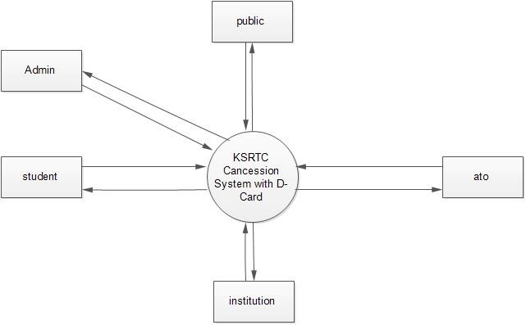

#### *LEVEL 1: ADMIN*

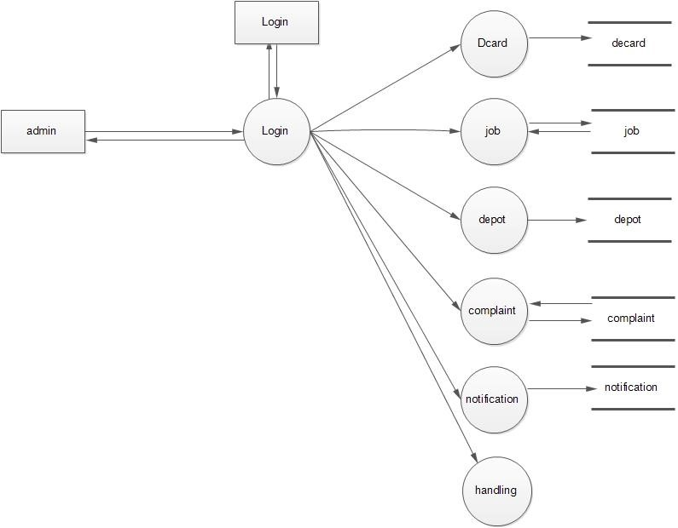

#### *LEVEL 1.1: ATO*

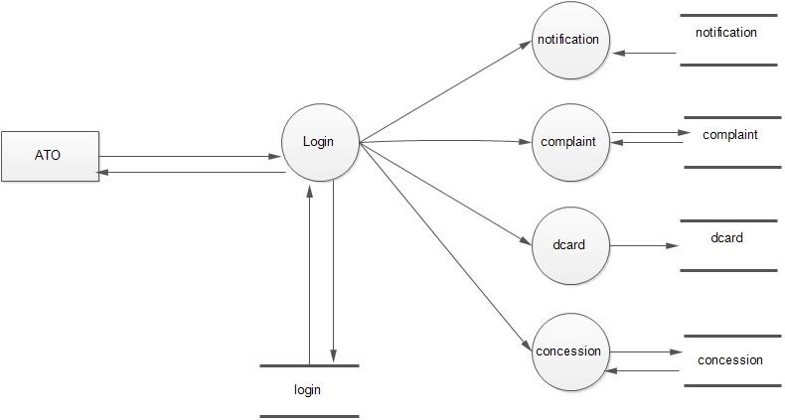

#### *LEVEL 1.2 : INSTITUTION*

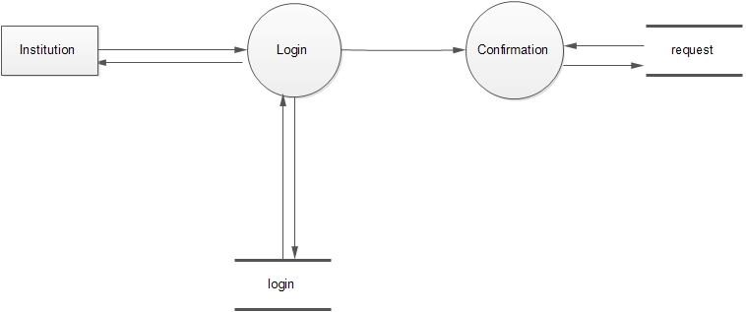

#### *LEVEL 1.3 : STUDENT*

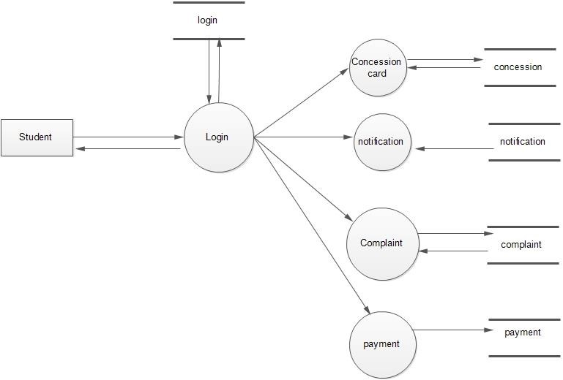

#### *LEVEL 1.4: PUBLIC*

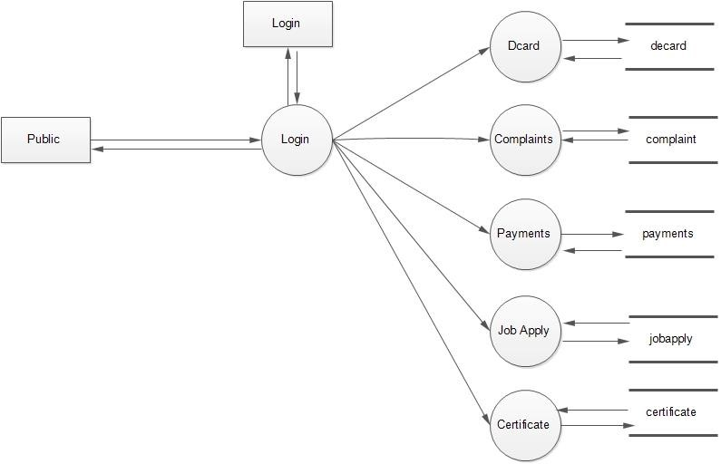

#### *LEVEL 1.5 : HANDLING*

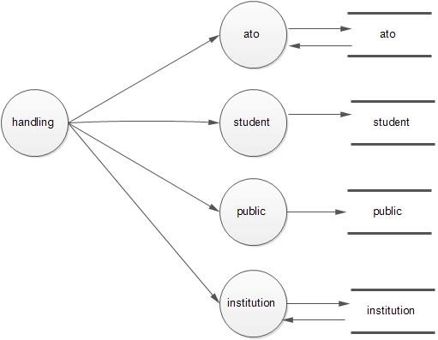

### 3.SYSTEM DESIGN

System design is the first step in the development phase for many engineered product or system. It may be defined as the process of applying various techniques and principles for the purpose of defining a device, a process or a system in sufficient detail to permits its physical realization. This Phase is the first step in moving from the problem domain to the solution domain. It is an iterative Process through which requirements are transmitted into a "blueprint" for constructing the software initially; the blue depicts a holistic view of software. That is design is represented at a high level of abstraction, functional and behavioral requirements.

#### 3.1 INPUT DESIGN

The input design is the process of converting the user-oriented inputs into the

computer-based format. The goal of designing input data is to make automation as easy and free from errors as possible. The input design requirements such as user friendliness, consistent format and interactive dialogues for giving the right message and help for the user at right time are also considered for the development of the project.

Inaccurate input data is the most common cause of error in processing data. Errors

entered by the data entry operators can be controlled by the input design. The arrangement of messages as well as placement of data, headings and titles on display screens or source document is also a part of input design. The design of input also includes specifying the means by which end user and system operators direct the system what action to take. The input design is the link between the information system and the user. It comprises the developing specification and procedures for data preparation and those steps that are necessary to put transaction data into a usable form for processing data entry.

In this project, all the necessary text boxes are validated. The input forms are

designed in Sublime. If any non-empty fields are not filled, it will display an error message and will wait until user types the necessary and correct input. Initially, to access the services of this software, the user has to log on with a login name and password which are validated. Once loggedon, he can access the various services, navigate to different profiles.

#### 3.2 OUTPUT DESIGN

Output generally refers to the results and information that are generated by the system.

When designing output, system analyst must accomplish the following.

* Determine what information to present.
* Decide whether to display, print the information and select the output medium
* Arrange the presentation of information in an acceptable format.
* Decide how to distribute the output to intended recipients.

The output design is specified on layout forms, sheets that describe the location characteristics, and formats of the column heading and pagination. In this project, output forms are designed in PHP. Each form has a heading or caption which specifies what services is been given to the users making the software user-friendly. All information are stored in the database and when anyone logs on and request for a service, the corresponding page is fetched from the server after validation and is rendered.

#### 3.3. DATA NORMALIZATION

Normalization is the process of efficiently organizing data in a database. Two goals or normalization are: eliminate redundant data and ensure data dependencies make sense. Both these goals reduce the amount of space a database consumes and ensure that data is logically stored. The database commonly has developed a series of guidelines for ensuring that databases are normalized. These are referred to as normal forms and are numbered from one through five.

#### TABLE DESIGN

##### 1.login

**Description:** Used to store username and password of users

|  |  |  |  |  |
| --- | --- | --- | --- | --- |
| **Column** | **Datatype** | **Size** | **Constraints** | **Description** |
| id | int | 10 | Primary Key | Store Login Id |
| lkey | char | 8 | Not Null | Store Login Key |
| email | varchar | 40 | Not Null | Store User‟s Email id |
| password | varchar | 32 | Not Null | Store User‟s Password |
| usertype | enum | „0‟,‟1‟,‟2‟,‟3‟ | Not Null | Store User Type |
| login_status | enum | „0‟,‟1‟,‟2‟ | Not Null | Store Login Status |

##### 2.ato

**Description:** Used to store ATO details

|  |  |  |  |  |
| --- | --- | --- | --- | --- |
| **Column** | **Datatype** | **Size** | **Constraints** | **Description** |
| id | int | 10 | Primary Key | Store Teacher Id |
| akey | char | 8 | Not Null | Store ATO Key |
| name | varchar | 30 | Not Null | Store ATO‟s Id Name |
| address | varchar | 40 | Not Null | Store ATO‟s Address |
| pincode | int | 6 | Not Null | Store ATO‟s Pincode |
| district | varchar | 20 | Not Null | Store ATO‟s District |
| gender | varchar | 10 | Not Null | Store ATO‟s Gender |
| dateofbirth | Date |  | Not Null | Store ATO‟s  DOB |
| depot | varchar | 30 | Not Null | Store ATO‟s Department |
| contact | int | 10 | Not Null | Store ATO‟s Contact |
| Loginid | int | 10 | Foreign Key | Store ATO‟s Login Id |

##### 3.student

**Description:** Used to store Student details

|  |  |  |  |  |
| --- | --- | --- | --- | --- |
| **Column** | **Datatype** | **Size** | **Constraints** | **Description** |
| id | int | 10 | Primary Key | Store Student Id |
| skey | char | 8 | Not Null | Store Student Key |
| name | varchar | 20 | Not Null | Store Student Name |
| address | varchar | 40 | Not Null | Store Student Address |
| pincode | int | 6 | Not Null | Store Student Pincode |
| district | varchar | 20 | Not Null | Store Student District |
| gender | varchar | 10 | Not Null | Store Student Gender |
| dateofbirth | date |  | Not Null | Store DOB |
| institution | varchar | 25 | Not Null | Store name of . institution |
| cource | varchar | 20 | Not Null | Store Student Cource |
| semester | varchar | 10 | Not Null | Store no of Semester |
| contact | int | 10 | Not Null | Store Student Contact |
| loginid | int | 11 | Not Null | Store Student Login Id |

##### 4.depot

**Description:** Used to store Deppot info

|  |  |  |  |  |
| --- | --- | --- | --- | --- |
| **Column** | **Datatype** | **Size** | **Constraints** | **Description** |
| id | int | 10 | Primary Key | Store Deppot Id |
| dkey | char | 8 | Not Null | Store Deppot Key |
| dippoid | varchar | 100 | Not Null | Store Deppot Id |
| name | varchar | 60 | Not Null | Store Deppot Name |
| district | varchar | 50 | Not Null | Store Deppot District |

##### 5.public

**Description:** Used to store public details

|  |  |  |  |  |
| --- | --- | --- | --- | --- |
| **Column** | **Datatype** | **Size** | **Constraints** | **Description** |
| id | int | 10 | Primary Key | Store user Id |
| pkey | char | 8 | Not Null | Store user Key |
| fullname | varchar | 20 | Not Null | Store user Name |
| address | varchar | 100 | Not Null | Store user Address |
| pincode | varchar | 10 | Not Null | Store user pincode |
| gender | varchar | 10 | Not Null | Store user Gender |
| Date_of_birth | varchar | 12 | Not Null | Store user dob |
| district | varchar | 30 | Not Null | Store User District |
| city | varchar | 30 | Not Null | Store User city |
| contactno | varchar | 30 | Not Null | Store User contact number |
| Loginid | int | 10 | Not Null | Store user Login Id |

##### 6.institution

**Description:** Used to store Institution details

|  |  |  |  |  |
| --- | --- | --- | --- | --- |
| **Column** | **Datatype** | **Size** | **Constraints** | **Description** |
| id | int | 10 | Primary Key | Store institution Id |
| ikey | char | 8 | Not Null | Store institution Key |
| institution | varchar | 30 | Not Null | Store Institution Type |
| name | varchar | 20 | Not Null | Store institution  Name |
| address | varchar | 100 | Not Null | Store institution Address |
| pincode | int | 6 | Not Null | Store Student Pincode |
| district | varchar | 30 | Not Null | Store institution District |
| city | varchar | 30 | Not Null | Store institution City |
| contact | varchar | 12 | Not Null | Store institution Contact |
| loginid | int | 10 | Not Null | Store institution Login Id |

##### 7.complaints

**Description:** Used to store Complaints

|  |  |  |  |  |
| --- | --- | --- | --- | --- |
| **Column** | **Datatype** | **Size** | **Constraints** | **Description** |
| id | int | 10 | Primary Key | Store complaint Id |
| okey | char | 8 | Not Null | Store Complaint Key |
| depot | varchar | 60 | Not Null | Store depot info |
| subject | varchar | 60 | Not Null | Store subject |
| complaint | varchar | 60 | Not Null | Store Complaints |
| currentdate | date |  | Not Null | Store Complaint Date |
| loginid | int | 10 | Not Null | Store Complaint login id |
| usertype | enum | („0‟,‟1‟,‟2‟) |  | Store type of user |
| reply | varchar | 60 | Not Null | Store replay |

##### 8.job

**Description:** Used to store job details

|  |  |  |  |  |
| --- | --- | --- | --- | --- |
| **Column** | **Datatype** | **Size** | **Constraints** | **Description** |
| id | int | 10 | Primary Key | Store job Id |
| jkey | char | 8 | Not Null | Store job Key |
| job | varchar | 60 | Not Null | Store job type |
| details | varchar | 100 | Not Null | Store job disc |
| depot | varchar | 100 | Not Null | Store job qualification |
| salary | varchar | 10 | Not Null | Store sallery details |
| qdetails | varchar | 50 | Not Null | Store job qualification |
| apply | varchar | 25 | Not Null | Apply with details |
| loginid | int | 10 | Not Null | Store job login id |
| currentdate | date |  | Not Null | Store job Date |

##### 9.job apply

**Description:** Used to store job applied details

|  |  |  |  |  |
| --- | --- | --- | --- | --- |
| **Column** | **Datatype** | **Size** | **Constraints** | Description |
| id | int | 10 | Primary Key | Store job apply Id |
| jakey | char | 8 | Not Null | Store job apply Key |
| jobid | varchar | 60 | Not Null | Store job applied id type |
| certificate | varchar | 100 | Not Null | Store certificate |
| currentdate | date |  | Not Null | Store job applied Date |
| loginid | int | 10 | Not Null | Store job applied login id |
| jstatus | enum | „0‟,‟1‟,‟2‟ | Not Null | Store Job applied status |
| interview | text |  |  | Interview details |

**10.request**

**Description:** Used to store request details

|  |  |  |  |  |
| --- | --- | --- | --- | --- |
| **Column** | **Datatype** | **Size** | **Constraints** | **Description** |
| id | int | 10 | Primary Key | Store request Id |
| rkey | char | 8 | Not Null | Store request Key |
| request | varchar | 60 | Not Null | Store request info |
| depotname | varchar | 60 | Not Null | Store destination info |
| studloginid | int | 10 | Not Null | Store student login info |
| currentdate | date |  | Not Null | Store request Date |
| loginid | int | 10 | Not Null | Store Complaint login id |
| confirmltr | text |  |  | Store confirmation letter |

**11.payment**

**Description:** Used to store Payment Transaction

|  |  |  |  |  |
| --- | --- | --- | --- | --- |
| **Column** | **Datatype** | **Size** | **Constraints** | **Description** |
| id | int | 10 | Primary Key | Store Payment Id |
| pakey | char | 8 | Not Null | Store Payment Key |
| cardno | varchar | 50 | Not Null | Store Card Number |
| nameoncard | varchar | 60 | Not Null | Store Card Name |
| cvv | varchar | 60 | Not Null | Store CVV Code |
| expirydate | varchar | 60 | Not Null | Store card Expiry Date |
| amount | varchar | 60 | Not Null | Store amount |
| loginid | varchar | 75 | Not Null | Store Payment login id |
| currentdate | date |  | Not Null | Store Payment date |

**12.concession**

**Description:** Used to store concession details

|  |  |  |  |  |
| --- | --- | --- | --- | --- |
| **Column** | **Datatype** | **Size** | **Constraints** | **Description** |
| id | int | 10 | Primary Key | Store concession Id |
| tkey | char | 8 | Not Null | Store concession Key |
| photo | text |  |  | Store photo of student |
| instname | varchar | 30 | Not Null | Store institution details |
| depot | varchar | 30 | Not Null | Store depot details |
| source | varchar | 30 | Not Null | Store from station details |
| destination | varchar | 100 | Not Null | Store station Details |
| month | varchar | 20 | Not Null | Store Month Details |
| meter | varchar | 80 | Not Null | Store distance Details |
| loginid | int | 10 | Not Null | Store student login id |
| currentdate | date |  | Not Null | Store concession applied Date |
| status | enum | „0‟,‟1‟,‟2‟ | Not Null | Store Concession status |
| paymentstatus | enum | „0‟,‟1‟,‟2‟ | Not Null | Store Payment status |

**13.dcard**

**Description:** Used to store dacrd information

|  |  |  |  |  |
| --- | --- | --- | --- | --- |
| **Column** | **Datatype** | **Size** | **Constraints** | **Description** |
| id | int | 10 | Primary Key | Store dcard Id |
| ckey | char | 8 | Not Null | Store card Key |
| cardtype | varchar | 20 | Not Null | Store type of card |
| amount | varchar | 20 | Not Null | Store Amount Details |
| month | int | 5 | Not Null | Store month |
| carddetails | varchar | 20 | Not Null | Store Card Details |

##### 14.dcardapply

**Description:** Used to store details of dcard applied

|  |  |  |  |  |
| --- | --- | --- | --- | --- |
| **Column** | **Datatype** | **Size** | **Constraints** | **Description** |
| id | int | 10 | Primary Key | Store D-Card Id |
| vkey | char | 8 | Not Null | Store D-Card Key |
| depot | varchar | 60 | Not Null | Store depot information |
| source | varchar | 100 | Not Null | Store D-Card Amount |
| destination | varchar | 20 | Not Null | Store destination Details |
| months | varchar | 15 | Not Null | Store Card Month Details |
| kilometer | varchar | 30 | Not Null | Store distance information |
| currentdate | date |  | Not Null | Store current date |
| loginid | int | 10 | Not Null | Store student login id |
| dcardid | int | 10 | Not Null | Store card id |
| dcardstatus | enum | „0‟,‟1‟,‟2‟ | Not Null | Store card status |

##### 15.notification

**Description:** Used to store notification details

|  |  |  |  |  |
| --- | --- | --- | --- | --- |
| **Column** | **Datatype** | **Size** | **Constraints** | **Description** |
| id | int | 10 | Primary Key | Store Id |
| nkey | char | 8 | Not Null | Store notification Key |
| notification | varchar | 100 | Not Null | Store notification |
| currentdate | date |  | Not Null | Store current date |

##### 16.kilometer

**Description:** Used to distance details.

|  |  |  |  |  |
| --- | --- | --- | --- | --- |
| **Column** | **Datatype** | **Size** | **Constraints** | **Description** |
| id | int | 10 | Primary Key | Store Id |
| kkey | char | 8 | Not Null | Store kilometer Key |
| source | varchar | 100 | Not Null | Store Source |
| destination | varchar | 60 | Not Null | Store Destination info |
| meter | varchar | 50 | Not Null | Store distance details |

## 3. SYSTEM TESTING AND IMPLEMENTATION

### 4.1 SYSTEM TESTING

Testing is the process of executing a program with the intent of finding any errors. A good test of course has the high probability of finding a yet undiscovered error. A successful testing is the one that uncovers a yet undiscovered error. A test is vital to the success of the system. System that makes logical assumptions that if all parts of this system are correct, then foal will be successfully achieved. The candidate system is subjected to variety of tests online like responsiveness, its value, stress and security.

System testing can be broadly classified into:

* Black box testing
* White box testing
* Unit testing
* Integration testing
* Validation testing

#### Black Box Testing

When computer software is considered b1ack box testing alludes to tests that are conducted at the software interface. A black box test examines some fundamental aspects of a system with little regard for the internal logical structure of the software.

Black box testing attempts to find errors in the following categories:

* Incorrect or missing function
* Interface errors
* Performance errors
* Errors in data structures or external database access
* Initialization and termination errors

In our application, we use a number of functions to perform operations. Using the black box testing we made sure that all functions are executing correctly by giving the required result.

#### White Box Testing

It is a testing method that uses control structure of procedural design to derive testing. Knowing the internal working of a product tests can be conducted to ensure that the internal operations perform according to specification and all internal components have been adequately exercised. White box testing of software is predicated on close examination of conditions and/or

loops test logical paths through the software. Using this testing method, the software engineer can do tests that:

Guarantee that all independent paths within a module have been exercised at least Once.

* Exercise all logical decisions on their true and false values.

* Execute all loops at their boundaries and within their operational bounds.

* Exercise internal data structures to ensure their validity.

Here all logical structures are tested in their true and false conditions. We

also made sure that all loops are performing well at their boundaries. For the checking appropriate data inputs are given and they are processed correctly. Individual functions are tested separately for each of the above conditions.

#### Unit Testing

This is the first level of testing. Here different functions used in the software development are split into different modules and tested to see whether they satisfy our needs. Code produced during the coding phase of the software development process and the internal logic of the module is tested here. After coding each function was tested individually. The logical errors found were corrected.

#### Integration Testing

This is systematic technique for constructing the structure while conducting tests touncover errors with interfacing. Here the different functions of software are combined into sub system, which are again tested. The various unit tested functions of the software were integrated and rigorous integration testing was conducted to make the application free of any interface errors that may occur. In this phase various functions are combined. Once the individual functions were tested, we tested the control hierarchy in a top-down integration manner.

#### Validation Testing

It provides the final assurance that the software meets all functional, behavioral and performance requirements. Then software changed for the better performance. When the application was made free of all logical and interface errors, validation testing was conducted by inputting dummy data to ensure that the software developed satisfied all the requirements of the user. This includes providing various valid and invalid inputs.

System tests carried out to validate dully developed system with a view assuring that it meets its requirements. There are essentially three kinds of system testing:

##### 1. Alpha Testing

It refers to the system testing that is carried out by the test team within the organization.

**2. Beta Testing**

Beta testing is the system testing performed by a selected group of friendly customers.

##### 3. Acceptance Testing

Acceptance testing is the system testing performed by the customer to determine whether or not to accept the delivery of the system. The application is tested to ensure the requirements. Different sets of input data are entered to validate the system. In all cases the system produces the reasonable output.

### SYSTEM IMPLEMENTATION

Implementation is the process of converting a new or revised system design into operation. It is the key stage in achieving a successful new system because, usually it reveals a lot of up heal. It must therefore be carefully planned and controlled. Apart from planning the two major tasks of preparing for implementation are education and training of users and testing of the system. Education of users should really take place much earlier in the project, Training has to be given to the web masters regarding the new system. Implementation is the stage of project where the theoretical design is turned into working system or it is the key stage in achieving a successful new system. Therefore, it must be carefully planned and controlled. It can also be considered to be the most crucial stage in achieving a successful new system and in giving the user confidence that the new system and in giving the user confidence that the new system will work and be effective.

Implementation is the final and important phase. It is the phase where theoretical design is turned into working system, which works for the user in the most effective manner. It involves careful planning, investigation of the present system and the constraints involved, user training, system testing and successful running of developed proposed system. The implementation process begins with preparing a plan for the implementation of the system. According to this plan the activities are to be carried out, discussions made regarding the equipment and resources and the additional equipment has to be acquired to implement the new system, The user tests the developed system and changes are made according to their needs. The testing phase involves the testing of a system using various kinds of data. This method also offers the greatest security since the old system can take over if the errors are found or inability to handle certain type of transactions while using the new system.

### FUTURE ENHANCEMENTS

Enhancement means adding, modifying or developing the code to support the changes in the specification. It is the process of adding new capabilities such as report, new interface without other systems and new features such as better screen or report layout. Every module in the system is being developed carefully stich that the future enhancements do not affect the basic performance of the system. In future we can add any links or services to the System very easily. Moreover, due to limited time allotted for the project, there are features, which I couldn't implement. Thus, the system offers the scope of future enhancement. As this software is reliable touse, any modification in accordance with the necessity of the user can be done for the future use. Any additional feature can be implemented very easily. So, what we call this software also a user friendly. Some of the future developments that can be incorporated in this software are

* In current system tender verification process is semi computerized we can implement it total computerized.
* This application is implementing all over the world.

**SYSTEM CODING**

#### atoreg.tpl

<html>

<head>

<title>ATO Registration</title>

</head>

<body>

<table align="center">

<form method="post" action="" enctype="multipart/form-data">

<input type="hidden" name="hide" value="h">

<tr><td>Full Name</td><td><input type="text" name="atoname"class="form-control"> </tr></td>

<tr><td>Address</td><td><textarea name="atoaddr"class="form-control"></textarea> </tr></td>

<tr><td>Pincode</td><td><input type="number" name="atopincode"class="form- control"></tr></td>

<tr><td>District</td><td><select name="atodis"class="form-control">

<option>Select</option>

<option>Thiruvananthapuram</option>

<option>Kollam</option>

<option>Pathanamthitta</option>

<option>Alappuzha</option>

<option>Kottayam</option>

<option>Idukki</option>

<option>Ernakulam</option>

<option>Thrissur</option>

<option>Palakkad</option>

<option>Malappuram</option>

<option>Kozhikkodu</option>

<option>Wayanad</option>

<option>Kannur</option>

<option>Kasargod</option>

</select>

<tr><td>Contact No.</td><td><input type="number" name="atocont"class="form- control"></tr></td>

<tr><td>Gender</td><td><input type="radio" name="atogender"value="male">Male

<input type="radio" name="atogender" value="Female">Female</tr></td>

<tr><td>Date of Birth</td><td><input type="Date" name="atodob"class="form-control"> </tr></td>

<tr><td>Dippo</td><td><select name="atodippo"class="form-control">

<option>Select</option>

<option>Ayoor</option>

<tr><td>Email</td><td><input type="Email" name="atoemail" class="form-control"> </tr></td>

<tr><td>Password</td><td><input type="password" name="atopassword"class="form- control"></tr></td>

<tr><td></td><td><input type="submit" value="Register"class="btn btn-success">

</tr></td>

</form>

</center>

</table>

</body>

</html>

#### Jobadd.tpl

<html>

<head>

<title>Job Adding</title>

</head>

<body>

<table align="center">

<form method="post" action="" enctype="multipart/form-data">

<input type="hidden" name="hide" value="h">

<tr><td>Job Category</td><td><select name="jobtype"class="form-control">

<option>Select</option>

<option>Conductor</option>

<option>Driver</option>

<option>Mechanic</option>

<option>Accountant</option>

<option>Peon</option>

</select>

<tr><td>Job Discription</td><td><textarea name="jobdisc"class="formcontrol"></textarea>

</tr></td>

<tr><td>Job Qualification</td><td><textarea name="jobqf"class="formcontrol"></textarea>

</tr></td>

<tr><td>Last Date for Apply</td><td><input type="Date" name="jobdate"class="form- control"></tr></td>

<tr><td></td><td><input type="submit" value="Submit"class="btn btn-success"> </tr></td>

</form>

</center>

</table>

</body>

</html>

#### atoreg.php

<?php include_once"settings/settings.php"; include_once"classes/userclass.php";

$obj=new userclass();

$k=$_COOKIE['kepkey'];

$sel=$obj->vdippo(); $smartyObj->assign("view",$sel); if(isset($_POST["hide"])AND($_POST["hide"])=="h")

{

if(isset($_POST['atoname'])AND($_POST['atoname'])!=null)

{

if(isset($_POST['atoaddr'])AND($_POST['atoaddr'])!=null)

{

if(isset($_POST['atopincode'])AND($_POST['atopincode'])!=null)

{

if(isset($_POST['atodis'])AND($_POST['atodis'])!=null)

{

if(isset($_POST['atocont'])AND($_POST['atocont'])!=null)

{

if(isset($_POST['atogender'])AND($_POST['atogender'])!=null)

{

if(isset($_POST['atodob'])AND($_POST['atodob'])!=null)

{

if(isset($_POST['atodippo'])AND($_POST['atodippo'])!=null)

{

if(isset($_POST['atoemail'])AND($_POST['atoemail'])!=null)

{

if(isset($_POST['atopassword'])AND($_POST['atopassword'])!=null)

{

$a=trim($_POST['atoname']);

$b=trim($_POST['atoaddr']);

$c=trim($_POST['atopincode']);

$d=trim($_POST['atodis']);

$e=trim($_POST['atocont']);

$f=trim($_POST['atogender']);

$g=trim($_POST['atodob']);

$h=trim($_POST['atodippo']);

$i=trim($_POST['atoemail']);

$j=trim($_POST['atopassword']);

$obj>ato($a,$b,$c,$d,$e,$f,$g,$h,$i,$j);

} else

echo"<script>alert('Passwordis empty!')</script>";

} else

echo"<script>alert('Email is empty!')</script>";

} else

echo"<script>alert('Dippo is empty!')</script>";

} else

echo"<script>alert('DOB is empty!')</script>";

} else

echo"<script>alert('Gender is empty')</script>";

} else

echo"<script>alert('Contact no. is empty!')</script>";

} else

echo"<script>alert('District is empty')</script>";

} else

echo"<script>alert('Pincode is empty')</script>";

} else

echo"<script>alert('Address is empty')</script>";

} else

echo"<script>alert('Name is empty')</script>";

}

$smartyObj->display('Subheader.tpl'); $smartyObj->display('ato reg.tpl');

$smartyObj->display('Footer.tpl');

?>

<?php

**jobadd.php** include_once"settings/settings.php"; include_once"classes/userclass.php";

$obj=new userclass();

$k=$_COOKIE['kepkey'];

$smartyObj->assign("job"); if(isset($_POST["hide"])AND($_POST["hide"])=="h")

{ if(isset($_POST['jobtype'])AND($_POST['jobtype'])!=null)

{ if(isset($_POST['jobdisc'])AND($_POST['jobdisc'])!=null)

{ if(isset($_POST['jobqf'])AND($_POST['jobqf'])!=null)

{ if(isset($_POST['jobdate'])AND($_POST['jobdate'])!=null)

{

$a=trim($_POST['jobtype']);

$b=trim($_POST['jobdisc']);

$c=trim($_POST['jobqf']);

$d=trim($_POST['jobdate']);

$obj->jobadd($a,$b,$c,$d,$k);

} else echo"<script>alert('Date is empty')</script>";

} else echo"<script>alert('Qualification is empty')</script>";

} else

echo"<script>alert('Discription is empty')</script>";

} else echo"<script>alert('Job Type is empty')</script>";

}

$smartyObj->display('ato subheader.tpl');

$smartyObj->display('job add.tpl');

$smartyObj->display('Footer.tpl');

?>

#### Userclass

<?php

class userclass

{

// function treg($a,$c,$d,$e,$f,$g,$h,$i,$file=NULL) function user($a,$c,$d,$e,$f,$g,$h,$i,$file=NULL)

{

$enc=md5($i);

$k1=uniquekey("login","kepkey");

$q="insert into login(kepkey,email,password,usertype,status) values('".$k1."','".$h."','".$enc."','1','1')";

$exe=mysql_query($q);

$key=uniquekey("user","ukey");

$id=keytoid("login","kepkey",$k1);

$qry="insertintouser(ukey,username,useraddr,userpincode,userdis,usercont,usergender,use rphoto, loginid) values('".$key."','".$a."','".$c."','".$d."','".$e."','".$f."','".$g."','".$file['na me']."','".$id."')"; // echo $qry;exit;

$photo="uploads/".$key; mkdir($photo);

$exe1=mysql_query($qry); if ($exe&&$exe1)

{ move_uploaded_file($file["tmp_name"],$photo."/".$file["name"]); echo "<script>alert('Registration Successful')</script>";

} else { echo"<script>alert('Registration unsuccessful')</script>";

}

}

function ato($a,$b,$c,$d,$e,$f,$g,$h,$i,$j)

{

$enc=md5($j);

$k1=uniquekey("login","kepkey");

$q="insert into login(kepkey,email,password,usertype) values('".$k1."','".$i."','".$enc."','2')";

$exe=mysql_query($q);

$key=uniquekey("ato","akey");

$id=keytoid("login","kepkey",$k1);

$qry="insertintoato(akey,atoname,atoaddr,atopin,atodis,atocont,atogender,atodob,atodippo ,loginid) values ('".$key.

"','".$a."','".$b."','".$c."','".$d."','".$e."','".$f."','".$g."','".$h."','".$id."')";

// echo $qry;exit;

$exe1=mysql_query($qry); if ($exe&&$exe1)

{ echo "<script>alert('Registration Successful')</script>";

} else { echo"<script>alert('Registration unsuccessful')</script>";

} } function stu($a,$b,$c,$d,$e,$f,$g,$h,$i,$j)

{

$enc=md5($j);

$k1=uniquekey("login","kepkey");

$q="insert into login(kepkey,email,password,usertype,status) values('".$k1."','".$i."','".$enc."','3','1')";

$exe=mysql_query($q);

$key=uniquekey("student","stkey");

$id=keytoid("login","kepkey",$k1);

$qry="insert into student(stkey,stname,staddr,stpin,stdis,stcont,stgender,stdob,stinst,loginid)values('".$key."'

,'".$a."', '".$b."','".$c."','".$d."','".$e."','".$f."','".$g."','".$h."','".$id."')";

// echo $qry;exit;

$exe1=mysql_query($qry); if ($exe&&$exe1)

{ echo "<script>alert('Registration Successful')</script>";

} else { echo"<script>alert('Registration unsuccessful')</script>";

} } function inst($a,$b,$c,$d,$e,$f,$g,$h)

{

$enc=md5($h);

$k1=uniquekey("login","kepkey");

$q="insert into login(kepkey,email,password,usertype) values('".$k1."','".$g."','".$enc."','4')";

$exe=mysql_query($q);

$key=uniquekey("institution","instkey");

$id=keytoid("login","kepkey",$k1);

$qry="insertintoinstitution(instkey,insttype,instname,instaddr,instpin,instdis,instcont,login d)values('".$key."','".$a."','".$b."','".$c."','".$d."','".$e."','".$f."','".$id."')";

// echo $qry;exit;

$exe1=mysql_query($qry); if ($exe&&$exe1)

{ echo "<script>alert('Registration Successful')</script>";

} else { echo"<script>alert('Registration unsuccessful')</script>";

}

}

### CONCLUSION

The new system has overcome most of the limitations of the existing system and works according to the design specification given. The developed systems dispense theproblem and meet the needs of by providing reliable and comprehensive information. All the requirements projected by the user have been met by the system. The newly developedsystem consumes less processing time and all the details are updated and processed immediately. since the screen provides online help messages and is, very user-friendly, any user will get familiarized with its usage. Modules are designed to be highly flexible so thatany failure requirements can be easily added to the modules without facing many problems.

**APPENDIX**

## Gantt Chart

Gantt chart shows time relationship between “events” of the production program has regarded as revolutionary in management. Gantt chart recognize the total program goals and it should be regarded as a series of inter-related supporting plan (or events), that people can comprehend and follow.

The following figure is the Gantt Chart of **KSRTC CONCESSION WITH D-CARD**

**SYSTEM**. The plan explains the task verses the time they will take to complete

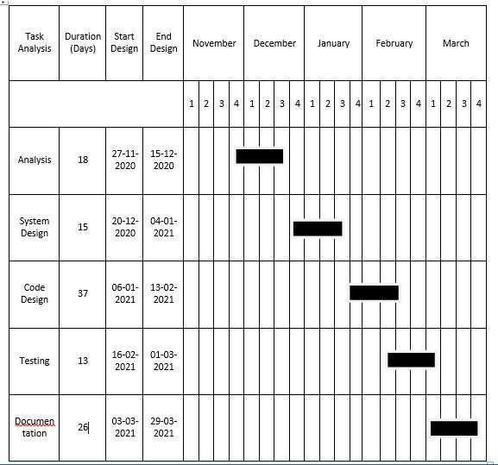

### MEETING MINUTES

#### MEETING MINUTES 1

**Date:**28/12/2021

**Time:** 10:00 am to 4:00 pm **Location:** Softzane Solutions, Ayur **Present:**

1. Amritha KP
2. Archana SR
3. Neenu Babu
4. Niji M Joy

On These day we have learned the fundamentals of PHP language and analyzed our project.

#### MEETING MINUTES 2

**Date:** 29/12/2021

**Time:** 10:00 am to 4:00 pm

**Location:** Softzane Solutions, Ayur

**Present:**

1. Amritha KP
2. Archana SR
3. Neenu Babu
4. Niji M Joy

##### Discussion of Management Plan

The admin module and ATO is assigned to **Amritha KP**. The User module and Concession Ticket is assigned to **Archana SR**. The Online route map module is assigned to **Neenu Babu** and The KSRTC job vacancy is assigned to **Niji M Joy**.

#### MEETING MINUTES 3

**Date:** 31/12/2021

**Time:** 10:00 am to 4:00 pm

**Location:** Softzane Solutions, Ayur

**Present:**

1. Amritha KP
2. Archana SR
3. Neenu Babu
4. Niji M Joy

We have downloaded templates that is required for the project. (Admin page, home page, Login page).

#### MEETING MINUTES 4

**Date:** 01/01/2022

**Time:** 10:00 am to 4:00 pm **Location:** Softzane Solutions **Present:**

1. Amritha KP
2. Archana SR
3. Neenu Babu
4. Niji M JoY

Each member is assigned to create the view forms for their module.

#### MEETING MINUTES 5

**Date:** 02/01/2022

**Time:** 10:00 am to 4:00 pm

**Location:** Softzane Solutions **Absent:**

Niji M Joy

**Discussion of Management Plan**

Amritha KP : design the login page and home page for user

. Archana SR : To design home page for ATO.

Neenu Babu : To design home page for Student.

#### MEETING MINUTES 6

**Date:** 03/1/2022

**Time:** 10:00 am to 4:00 pm

**Location:** Softzane Solutions, Ayur

**Present:**

1. Archana Sr
2. Neenu Babu
3. Niji M Joy

**Absent:**

Amritha KP

**Discussion of Management Plan**

Archana SR : To set the profile edit of the User.

Neenu Babu : To set the profile edit of the ATO.

Niji M Joy : To set the profile edit of the student.

#### MEETING MINUTES 7

**Date:** 04/01/2022

**Time:** 10:00 am to 4:00 pm

**Location:** Softzane Solutions, Ayur

**Present:**

1. Amritha KP
2. Neenu Babu **Absent:**

Archana SR Niji M Joy

Database connectivity has been done and sample data has been provided.

#### MEETING MINUTES 7

**Date:** 05/01/2022

**Time:** 10:00 am to 4:00 pm

**Location:** Softzane Solutions, Ayur

**Present:**

1. Amritha KP
2. Archana SR
3. Neenu Babu
4. Niji M Joy

We completed institution module (Registration and Home page).and we completed Registration request from ATO and Institution.

#### MEETING MINUTES 8

**Date:** 15/01/2022

**Time:** 10:00 am to 4:00 pm

**Location:** Softzane Solutions, Ayur

**Present:**

1. Amritha KP
2. Archana SR
3. Neenu Babu
4. Niji M Joy

##### Discussion Of Management Plan

Concession Ticket Contd., D-Card Applying.

**FORM LAYOUTS**

#### LOGIN PAGE

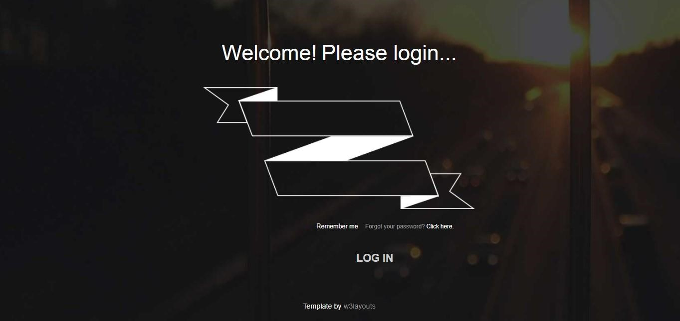

##### HOME PAGE

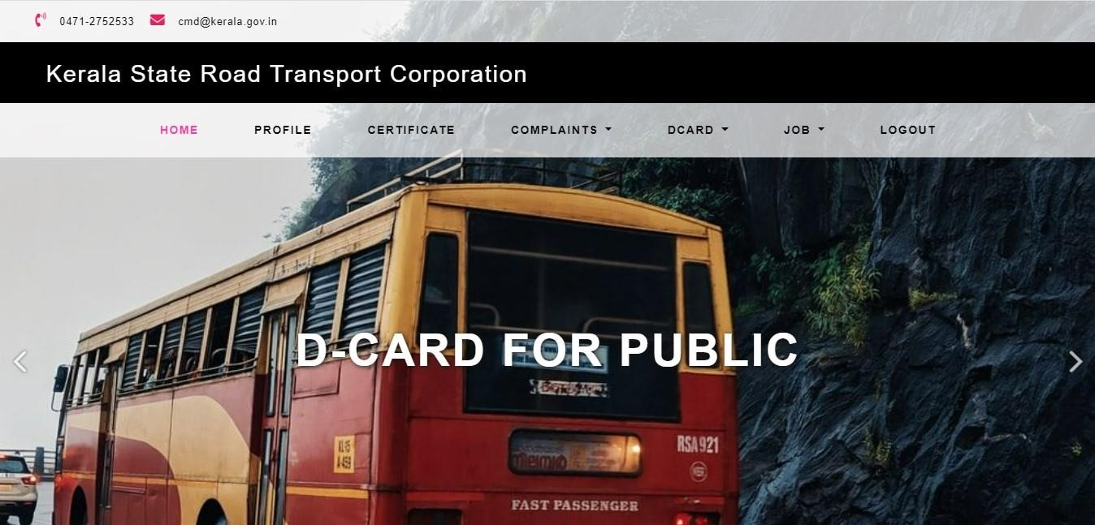

###### STUDENT REGISTRATION

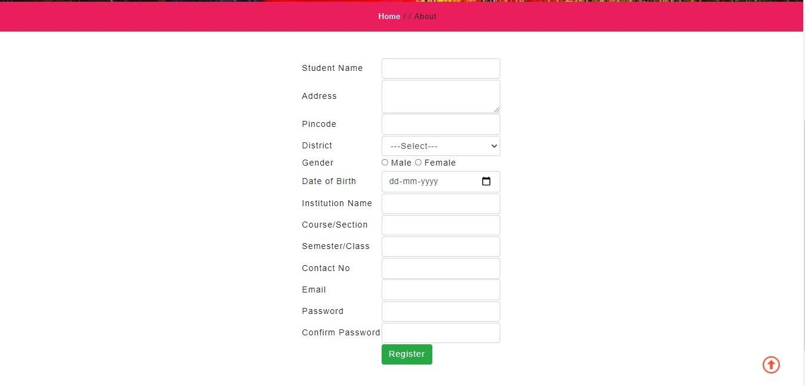

###### ATO REGISTRATION

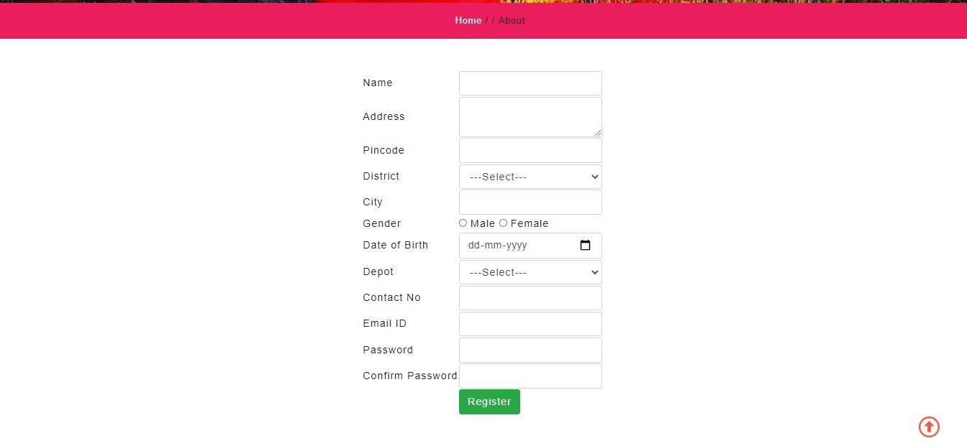

**INSTITUTION REGISTRATION**

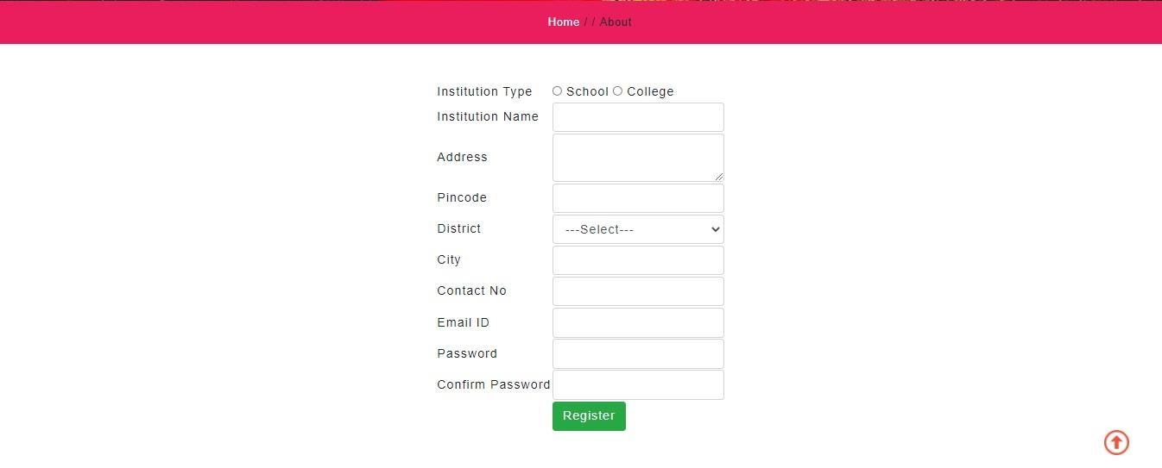

##### ATO HOME PAGE

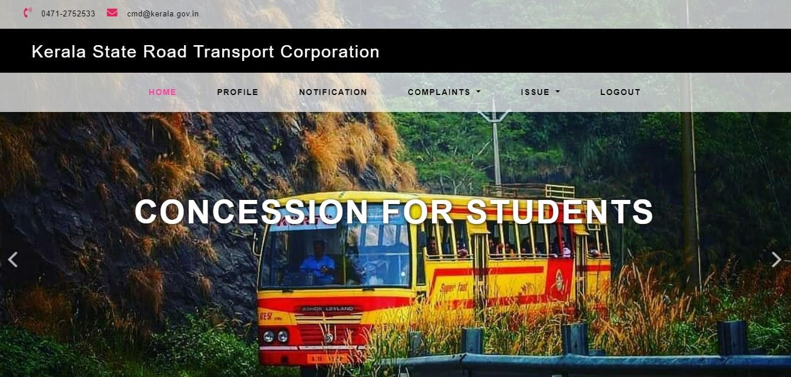

##### INDEX PAGE

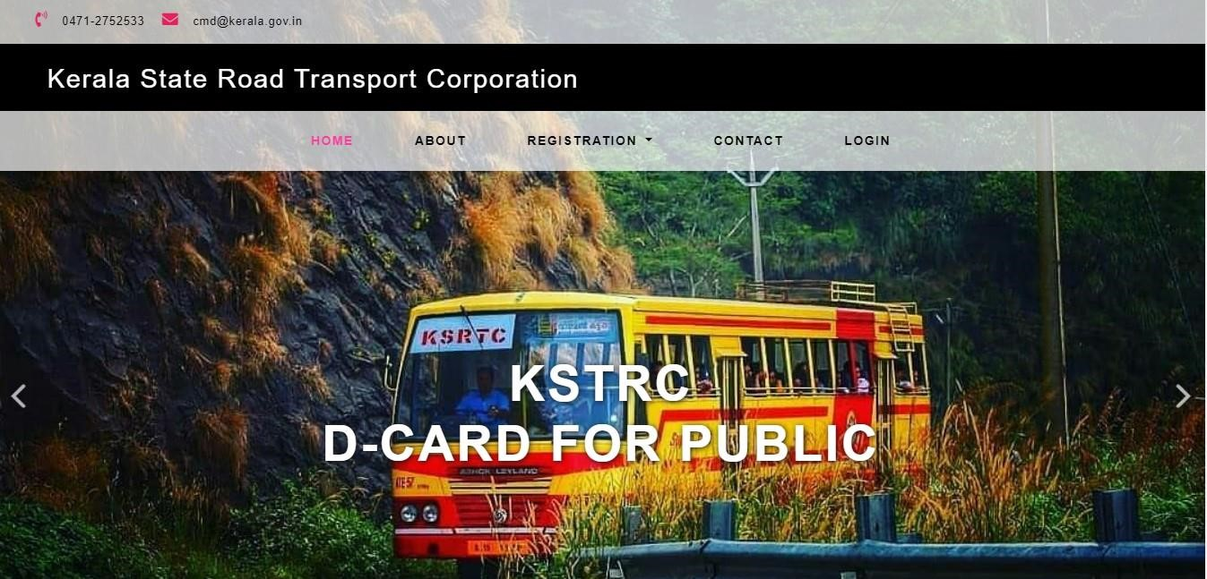

### 10.REFERENCES

#### I. Books

1. Julie C Meloni,” PHP, MySQL and Appache”, Pearson Education
2. Rajib Mall, “Fundamentals of Software Engineering”, PHI
3. V.K Jain, “Advanced Programming in Web Design”, Cyber Tech Publications
4. Ramon A.Mata-toledo and Pauline Cushman,” Fundamentals of Relational Data Bases”, SchaumOutlines, MaGraw Hills 5. Idolia Cox Collier, “Medical Surgical Nursing”, Third Edition

#### II. Websites

1. <http://localhost/Aanavandi/index.php>
2. <https://www.w3schools.com/php/default.asp>
3. [https://www.php.com](https://www.php.com/)
4. [https://www.keralartc.com](https://www.keralartc.com/)
5. [https://www.aanavandi.com](https://www.aanavandi.com/)